**PROJECT NAME : SWAP SHOP**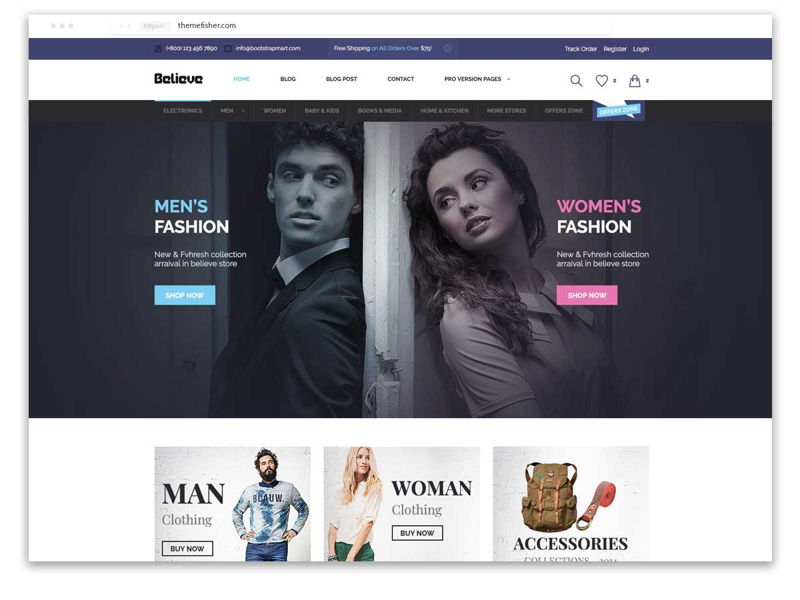

**OVERVIEW: Its an e-commerce website for buying a all accessories for Mens,Womens and for Kids everythings you want**

**1.HOME PAGE**

**\*Logo of my page**

**\*Sliders to show what are the category**

**\*Trending Images**

**\*Search Bar**

**2.CODE USED**

**\*HTML**

**\*CSS**

**3.ACCOUNT SIGIN PAGE**

**\*EMAIL ID**

**\*PASSWORD**

**\*SIGNIN**

**4.PAYMENT PAGE**

**\*ADDESS SELECTION**

**\*MOBILE NO**

**\*PAYMENT METHOD**

**@COD(OR)GPAY,PHONEPAY,NET BANKING**